**How to Balance or Disrupt a Game**

**Game Disruptor 2.0 Documentation**

# Overview

This document outlines the simple steps to balance a game using the game disruptor tool. Before reading this document, please make sure you have setup your game correctly and followed the steps listed in the “Game Disruptor 2 - Add Game Documentation.docx” document.

# Open Project

The first step in being able to balance a game or simulator with the game disruptor tool is to open the project you have already created. A project can be opened by clicking the “Open or Import” button on the welcome screen or selecting the project from left panel, see Figure 1.

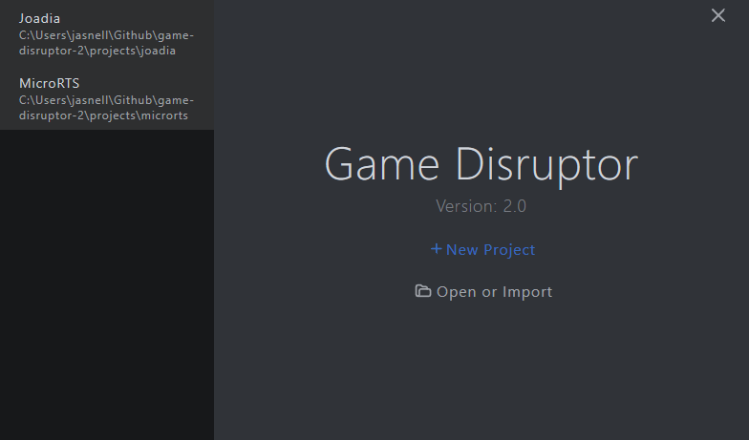

**Figure 1: The game disruptor welcome screen shown after loading.**

Opening a project presents a screen split into five sections, game variables, case injection, scenario parameters, evolution parameters and distributed processing. See Figure 2.

**Figure 2: An example of a loaded project.**

## Game Variables

This section is where the game variables for the loaded project are listed. Each of the game variables values can be quickly updated to allow for manual exploration. The values of each variable are also used when adding or viewing entries to be injected by case injection.

## Case Injection

The case injection list box holds the user crafted solutions that are injected during the game balancing process. This allows a user to bias the evolutionary search towards certain solutions and use their expert knowledge to help with the search process. Clicking the add button in the case injection area will take the values defined in the game variables section and add them as a case to be injected. Cases may also be removed by selecting an entry in the case injection list box and clicking the remove button.

## Scenario Parameters

The scenario parameters can be used to control aspects of the scenario such as the scenario level to use, the amount of uncertainty or targets that the game disruptor tools optimized solutions aim to achieve.

## Evolution Parameters

This section allows a user to control the hyper parameters used by the multi-objective genetic algorithm. Every project has the same list of eight hyper parameters that can be tuned. This includes the seed, number of generations, size of the population of solutions, the mutation-rate, the crossover-rate, the simulation count per solution, the number of cases to inject during the evolution and how often to inject cases into the evolutionary process.

## Distributed Processing

The game disruptor tool automatically by default uses multi-processing to distribute the evaluation of solutions across a multiple cores. For complicated games with many game variables the evolutionary process may still take considerable amount of time. The distributed processing feature allows a user to spread the workload across not only multiple cores but multiple machines as well. To distribute the work across multiple machines each machine must be connected to the same local area network or Wi-Fi router. One machine must become the host by clicking the “Become Host” button, while all remaining machines must enter the IP address of the host and click the “Connect to Host” button.

# Running Evolution

Once all the project parameters have been set to the desired values the evolutionary balancing or disrupting process can begin by clicking the “Evolve” button, located under the evolution parameters section. This will start the evolution process and open the evolution running screen.

**Figure 3: Example a game being balanced or disrupted using evolution.**

The evolution screen is updated in real-time and provides a summary of where the solutions have been found so far and a list of the solutions along the current pareto front. This screen can be divided into five sections, the multi-objective performance plots, the pareto front list box, the statistics summary and the distribution plots.

## Performance Plots

In real-time after each generation fitness for each solution evaluated as well as all previously evaluated solutions are plotted based on their objective measures achieved. This allows the user to analyse where all the solutions of the evolutionary process have so found been found under the pareto front. Additionally, a separate plot shows only solutions that lie on the pareto front for the two objectives.

## Pareto List

This section holds a list of all the solutions that have found to lie on the pareto front. Selecting an entry will update the statistics and distributions sections to show the relevant information for that specific solution.

## Game Variables

The game variable values for a solution are shown in this section for a selected solution in the pareto front list. If no solution has been selected by default the first entry in the pareto front is shown.

## Statistics

This section details the statistics reported by the game or simulator for the selected solution within the pareto front list. If no solution has been selected by default the first entry in the pareto front is shown.

## Distributions

The distributions section holds the plots for all the distributions reported by the game or simulator for the selected solution in the pareto front list. All the generated plots and histograms for all the solutions in the pareto front are saved to the experiments folder created when running the evolution process.

# Summary

This document outlines the simple steps required to be able to balance or disrupt a game using the game disruptor tool. Additionally, each of the important sections in each of the relevant screens are explained as to their purpose and what they can be used for. If the evolutionary process fails to run or errors part way through, ensure the setup steps have been followed correctly in the “Game Disruptor 2 - Add Game Documentation” document.